CREATE TABLES:-

CREATE TABLE LOCATION
(Location_ID INT NOT NULL PRIMARY KEY
,Regional_Group VARCHAR(20)
);
INSERT INTO LOCATION(Location_ID,Regional_Group) VALUES (122,'NEW YORK');
INSERT INTO LOCATION(Location_ID,Regional_Group) VALUES (123,'DALLAS');
INSERT INTO LOCATION(Location_ID,Regional_Group) VALUES (124,'CHICAGO');
INSERT INTO LOCATION(Location_ID,Regional_Group) VALUES (167,'BOSTON');
INSERT INTO LOCATION(Location_ID,Regional_Group) VALUES (162,'BOSTON');
INSERT INTO LOCATION(Location_ID,Regional_Group) VALUES (166,'BOSTON');
INSERT INTO LOCATION(Location_ID,Regional_Group) VALUES (165,'BOSTON');

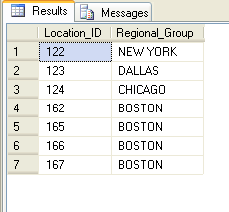

CREATE TABLE DEPARTMENT
(Department_ID INT NOT NULL PRIMARY KEY
,Name VARCHAR(20)
,Location_ID INT
);
INSERT INTO DEPARTMENT(Department_ID,Name,Location_ID) VALUES (10,'ACCOUNTING',122);
INSERT INTO DEPARTMENT(Department_ID,Name,Location_ID) VALUES (20,'RESEARCH',124);
INSERT INTO DEPARTMENT(Department_ID,Name,Location_ID) VALUES (30,'SALES',123);
INSERT INTO DEPARTMENT(Department_ID,Name,Location_ID) VALUES (40,'OPERATIONS',167);

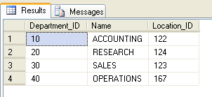
CREATE TABLE JOB
(Job_ID INT NOT NULL PRIMARY KEY
,Functions VARCHAR(30)
);

INSERT INTO JOB(Job_ID,Functions) VALUES (667,'CLERK');
INSERT INTO JOB(Job_ID,Functions) VALUES (668,'STAFF');
INSERT INTO JOB(Job_ID,Functions) VALUES (669,'ANALYST');
INSERT INTO JOB(Job_ID,Functions) VALUES (670,'SALESPERSON');
INSERT INTO JOB(Job_ID,Functions) VALUES (671,'MANAGER');
INSERT INTO JOB(Job_ID,Functions) VALUES (672,'PRESIDENT');

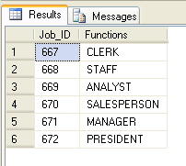
CREATE TABLE EMPLOYEE
(EMPLOYEE_ID INT NOT NULL PRIMARY KEY,
LAST_NAME VARCHAR(50),
FIRST_NAME VARCHAR(50),
MIDDLE_NAME VARCHAR(50),
JOB_ID INT,
MANAGER_ID INT,
HIREDATE DATE,
SALARY INT,
COMM INT,
DEPARTMENT_ID INT
);
INSERT INTO EMPLOYEE (EMPLOYEE_ID,LAST_NAME,FIRST_NAME,MIDDLE_NAME,JOB_ID,MANAGER_ID,HIREDATE,SALARY,COMM,DEPARTMENT_ID) VALUES (7969,'SMITH','JOHN','Q',667,7902,'17-DEC-1984',800,NULL,20);
INSERT INTO EMPLOYEE (EMPLOYEE_ID,LAST_NAME,FIRST_NAME,MIDDLE_NAME,JOB_ID,MANAGER_ID,HIREDATE,SALARY,COMM,DEPARTMENT_ID) VALUES (7499,'ALLEN','KEVIN','J',670,7698,'20-FEB-1985',1600,300,30);
INSERT INTO EMPLOYEE (EMPLOYEE_ID,LAST_NAME,FIRST_NAME,MIDDLE_NAME,JOB_ID,MANAGER_ID,HIREDATE,SALARY,COMM,DEPARTMENT_ID) VALUES (7505,'DOYLE','JEAN','K',671,7839,'04-APR-1985',2850,NULL,30);
INSERT INTO EMPLOYEE (EMPLOYEE_ID,LAST_NAME,FIRST_NAME,MIDDLE_NAME,JOB_ID,MANAGER_ID,HIREDATE,SALARY,COMM,DEPARTMENT_ID) VALUES (7506,'DENNIS','LYNN','S',671,7839,'15-MAY-1985',2750,NULL,30);
INSERT INTO EMPLOYEE (EMPLOYEE_ID,LAST_NAME,FIRST_NAME,MIDDLE_NAME,JOB_ID,MANAGER_ID,HIREDATE,SALARY,COMM,DEPARTMENT_ID) VALUES (7507,'BAKER','LESLIE','D',671,7839,'10-JUN-1985',2200,NULL,40);
INSERT INTO EMPLOYEE (EMPLOYEE_ID,LAST_NAME,FIRST_NAME,MIDDLE_NAME,JOB_ID,MANAGER_ID,HIREDATE,SALARY,COMM,DEPARTMENT_ID) VALUES (7521,'WARK','CYNTHIA','D',670,7698,'22-FEB-1985',1250,500,30);

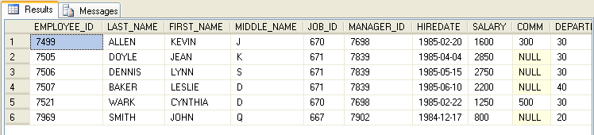
CREATE TABLE PERSONS
(P_ID int not null primary key,
LastName varchar (20),
FirstName varchar (20),
Addres Varchar (100),
City varchar (20)
);

INSERT INTO PERSONS (P_ID,LastName,FirstName,Addres,City) VALUES
(1,'Hansen','Ola','Timoteivn 10','Sandnes');
INSERT INTO PERSONS (P_ID,LastName,FirstName,Addres,City) VALUES
(2,'Svendson','Tove','Borgvn 23','Sandnes');
INSERT INTO PERSONS (P_ID,LastName,FirstName,Addres,City) VALUES
(3,'Pettersen','Kari','Storgt 20','Stavanger');
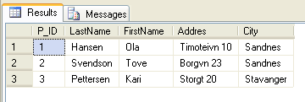

CREATE TABLE ORDERS
(O_ID int not null primary key,
OrderNo int,
P_id int,
);

INSERT INTO ORDERS(O_ID,OrderNo,P_ID) VALUES
(1,77895,3);
INSERT INTO ORDERS(O_ID,OrderNo,P_ID) VALUES
(2,44678,3);
INSERT INTO ORDERS(O_ID,OrderNo,P_ID) VALUES
(3,22456,1);
INSERT INTO ORDERS(O_ID,OrderNo,P_ID) VALUES
(4,24562,1);
INSERT INTO ORDERS(O_ID,OrderNo,P_ID) VALUES
(5,34764,15);
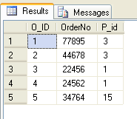

- list out first name, last name,salary,commision for all employee
SQL:- select first_name,last_name,salary,comm from EMPLOYEE;
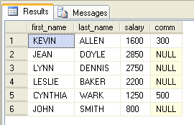

- List out employee_id,last name, department id for all employees and rename employee id as ID of the employee,last name as "name of the
employee",department id as "department ID"
SQL:- select employee_id "id of employee",last_name "name",DEPARTMENT_ID "department ID"from employee;
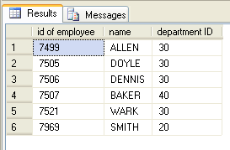
- List out the employee salary with there names only.

SQL:-
Select LAST_NAME,FIRST_NAME,MIDDLE_NAME,SALARY * 12 from EMPLOYEE;
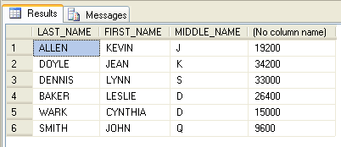

Select LAST_NAME,FIRST_NAME,MIDDLE_NAME,SALARY,SALARY * 12 from EMPLOYEE;
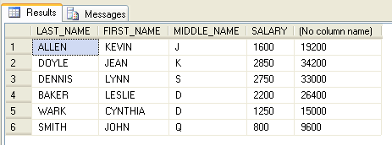

Select LAST_NAME,FIRST_NAME,MIDDLE_NAME,SALARY * 12 "Years Salary" from EMPLOYEE;

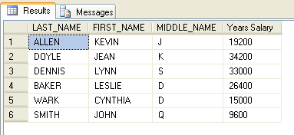

Where Conditions:-

- List out the details about “SMITH” only

Select * from EMPLOYEE where LAST_NAME='SMITH';

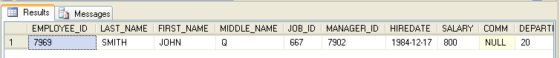

5)List out the employee who are working in deparment 20.

Select * from EMPLOYEE where DEPARTMENT_ID=20;

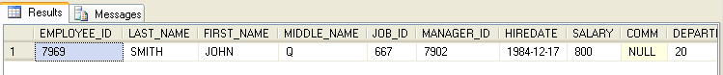

- List out the employee who are earning salary between 1000 to 3000

SQL:-
Select * from EMPLOYEE where SALARY between 1000 and 3000;
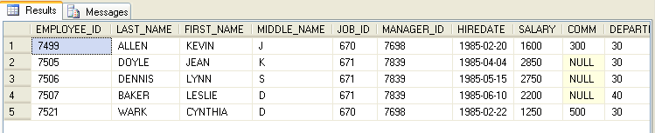

- List out the employee who are working in department 10 or 30

Select * from EMPLOYEE where DEPARTMENT_ID in (10,20);

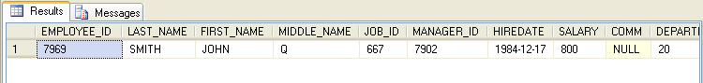

- List out the employee who are not working in department 10 or 30

Select * from EMPLOYEE where DEPARTMENT_ID not in (10,30);

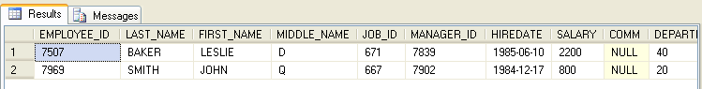

- List out the employees whose name starts with “S”.

Select * from EMPLOYEE where LAST_NAME like 'S%'

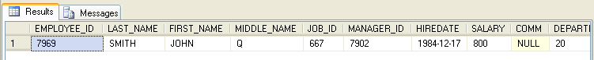

- List out the employees whose name starts with “S” and ends with “H”.

Select * from EMPLOYEE where LAST_NAME like 'S%H'

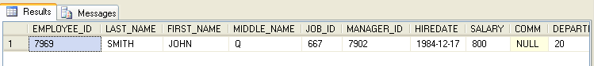

- List out the employees whose name length is 5.

Select * from EMPLOYEE where len(LAST_NAME)=5

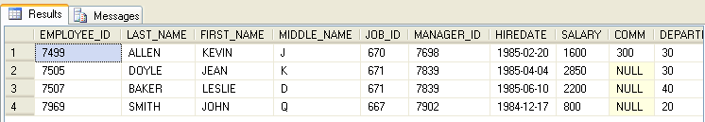

- List out the employees whose name length is 5 and start with “S”.

Select * from EMPLOYEE where len(LAST_NAME)=5 and LAST_NAME like 's%'

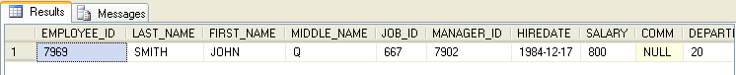

- List out the employee who are working in department 10 and draw the salaries more than 3500.

Select * from EMPLOYEE where DEPARTMENT_ID=10 and SALARY > 3500;

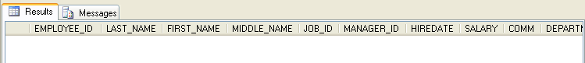

- List out the employee who are working in department 30 and draw the salaries more than 1500.

Select * from EMPLOYEE where DEPARTMENT_ID=30 and SALARY > 1500;

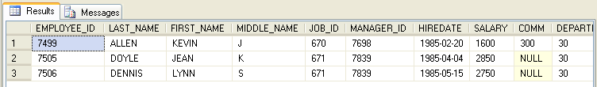

- List out the employee who are working in department 30 and draw the salaries less than 1500.

Select * from EMPLOYEE where DEPARTMENT_ID=30 and SALARY < 1500;

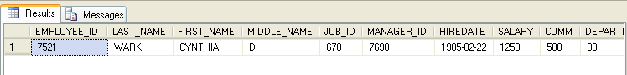

- List out employee who are not receiving commision.

Select * from EMPLOYEE where COMM is null;

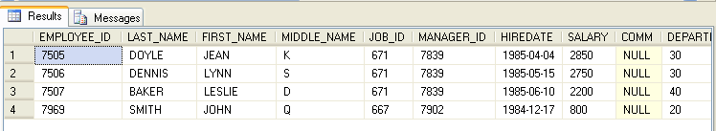

- List out employee who are receiving commision.

Select * from EMPLOYEE where COMM is not null;
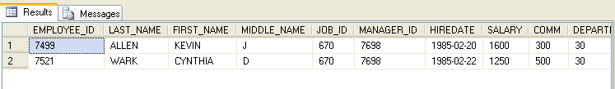

- List out the employee id,last name in ascending order based on employee id

Select EMPLOYEE_ID,LAST_NAME from EMPLOYEE order by EMPLOYEE_ID ASC;

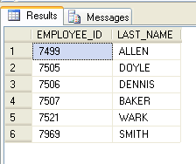
- List out the employee id,lats name,first name in ascending order based on employee id

Select EMPLOYEE_ID,LAST_NAME,FIRST_NAME from EMPLOYEE order by EMPLOYEE_ID DESC;

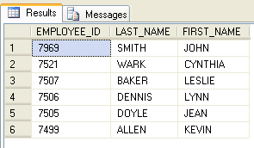

- list out the employee id,name in descending order based on salary.

Select EMPLOYEE_ID,LAST_NAME,FIRST_NAME from EMPLOYEE order by SALARY DESC;

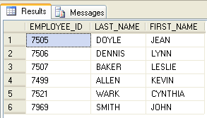

- list out the employee details according to their last_name in ascending order and salary in descending order.

list out the employee details according to their last_name in ascending order and then on department_id in descending order.

22) How many employee who are working in different departments wise in the organization.

Select DEPARTMENT_ID ,count(*) from EMPLOYEE group by DEPARTMENT_ID;

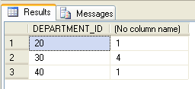

Select DEPARTMENT_ID ,count(*) "NUMBER" from EMPLOYEE group by DEPARTMENT_ID;

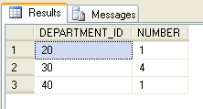

23) List out the department wise maximum salary,minimum salary,avarage salary of the employee.

Select DEPARTMENT_ID ,count(*)"NUMBER",MAX (SALARY)"MAXIMUM_SALARY",MIN (SALARY)"MINIMUM_SALARY",AVG (SALARY)"AVARAGE_SALARY"from EMPLOYEE group by DEPARTMENT_ID;

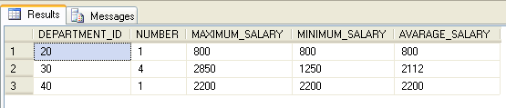

24)List out the job wise maximum salary, minimum salary, avarage salaries of the employee.

Select job_id,MAX (SALARY)"MAXIMUM_SALARY",MIN (SALARY)"MINIMUM_SALARY",AVG (SALARY)"AVARAGE_SALARY"from EMPLOYEE group by JOB_ID;
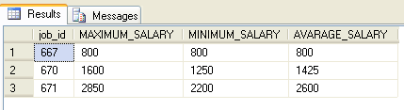

List the emps in the asc order of Designations of those joined after the second half of 1981.

25) List out the number of employees joined in every month in asecnding order .

26) list out the number of employees for each month anf year ,in ascending order based on the year, month
27) lit out the department id having atleast four employee.
28) How many employee s in january month.
29) How many employees who are joined in January or September month.
30) How many employees who are joined in 1985.
31) How many employees who are joined in each month of 1985.
32) How many employees who are joined in March 1985.
33) which is the department id having greater than or equal to 3 employees joined in april 1985.

SUB QUARIES:-

34) Display the employee who got the maximum salary.

select * from EMPLOYEE where SALARY =(select MAX(SALARY) from EMPLOYEE);

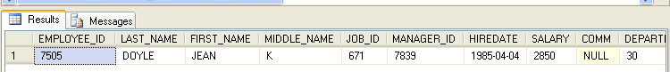

select MAX(SALARY)"MAXIMUM_SALARY" from EMPLOYEE;

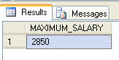

35) Display the emplyee who are working in sales department.

Select * from EMPLOYEE where DEPARTMENT_ID in (Select DEPARTMENT_ID from DEPARTMENT where Name = 'SALES')

Select * from EMPLOYEE where DEPARTMENT_ID = (Select DEPARTMENT_ID from DEPARTMENT where Name = 'SALES')

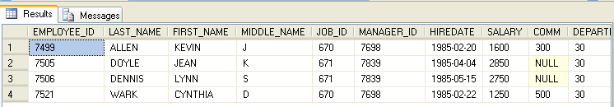

36) Display the employee who are working as “Clerk”.
Select * from EMPLOYEE where JOB_ID in (Select JOB_ID from JOB where Functions ='CLERK');

37) Display the employee who are working in “New York”
Select * from EMPLOYEE Where DEPARTMENT_ID in (Select Department_ID from DEPARTMENT where Location_ID in (Select Location_ID from LOCATION where Regional_Group='NEW YORK'));
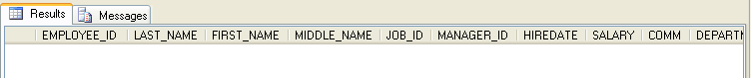

37) Display the employee who are working in “DALLAS”

Select * from EMPLOYEE Where DEPARTMENT_ID in (Select Department_ID from DEPARTMENT where Location_ID in (Select Location_ID from LOCATION where Regional_Group='DALLAS'));

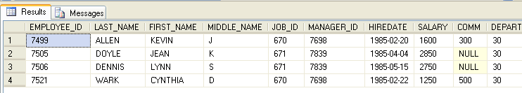

38) Find out number of employees working in”Sales”department.

Select COUNT (EMPLOYEE_ID)"NUMBER OF EMPLOYEE" from EMPLOYEE where DEPARTMENT_ID in (Select Department_ID from DEPARTMENT where Name='SALES')

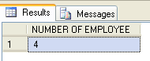

39) Update the employee salaries ,who are working as Cleark on the basis of 10%.
Update EMPLOYEE set SALARY= SALARY * 10/100 where JOB_ID in (Select JOB_ID from JOB where Functions ='CLERK');

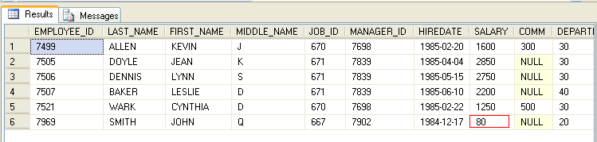

Update EMPLOYEE set SALARY= SALARY * 10 where JOB_ID in (Select JOB_ID from JOB where Functions ='CLERK');

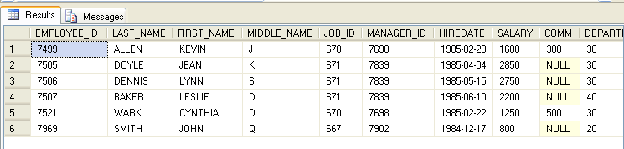

40) Delete the employee who are working in accounting department.

Delete from EMPLOYEE where DEPARTMENT_ID in (Select Department_ID from DEPARTMENT where Name='ACCOUNTING')

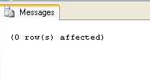
Delete from EMPLOYEE where DEPARTMENT_ID in (Select Department_ID from DEPARTMENT where Name='RESEARCH')
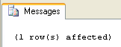

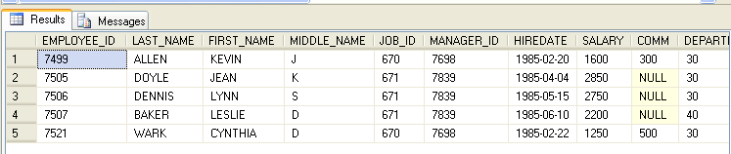

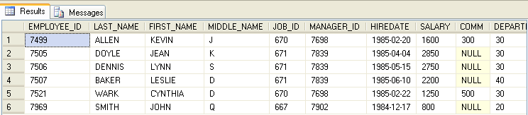

41) Display the second heighest salary drawing employee details.

Select * from EMPLOYEE where SALARY = (Select MAX (SALARY)from EMPLOYEE where SALARY < (Select MAX(SALARY)from EMPLOYEE))

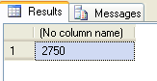

42) Display the nth highest salary drawing employee details.

SUB QUERY OPERATORS : (ALL, ANY ,SOME,EXISTS)

43) listout the employees who earn more than every employee in department 30.
44) List out the employee who earn more than the lowest salary in department 30.
45) find out whose department does not have any employee.
46) find out which department does not have any employee.
47) Find out the employees who earn greater than the avarage salary for their department.

SIMPLE JOINS

48) list out employees with their departments name.

select EMPLOYEE.FIRST_NAME,EMPLOYEE.LAST_NAME,DEPARTMENT.Name from EMPLOYEE inner join DEPARTMENT on EMPLOYEE.DEPARTMENT_ID=DEPARTMENT.Department_ID

49) Display employees with their designations jobs.
50) Display the employees with their department name and regional groups.
51) How many employee who are working in different departments and display the department name.
52) How many emplyee who are working in sales department.
53) which is the department having greater than or equal to 5 employees and display the department name in ascending order.
54) How many jobs in department with designation.
55) How many employee working in “New York”

NON- EQUI JOINS:-

56) Display employee details with salary grades.
57) List out the number of employees on grade wise.
58) Display the employ salary grades and no. of employee between 2000 to 5000 range of salary.

SELF JOIN:-
59) Display the employee details with all departments.
60) Display the employee details who earn more than their managers salaries.
61) Show the number of employee working under manager

OUTER JOIN:-

62)Display employee details with all departments.
63) Display all employees in sales or operations department.

SET OPERATORS:-

64) list out the distinct jobs in sales and accounting Departments.
65) List out the All jobs in sales and accounting department.
66) List out the common jobs in Research and accounting department in ascending order.

SQL QUERIES:

1) Display the details of all employees
SQL>Select * from emp;

2) Display the depart information from department table
SQL>select * from dept;

3) Display the name and job for all the employees
SQL>select ename,job from emp;

4) Display the name and salary for all the employees
SQL>select ename,sal from emp;

5) Display the employee no and totalsalary for all the employees
SQL>select empno,ename,sal,comm, sal+nvl(comm,0) as”total salary” from
emp

6) Display the employee name and annual salary for all employees.
SQL>select ename, 12*(sal+nvl(comm,0)) as “annual Sal” from emp

7) Display the names of all the employees who are working in depart number 10.
SQL>select emame from emp where deptno=10;

8) Display the names of all the employees who are working as clerks and
drawing a salary more than 3000.
SQL>select ename from emp where job=’CLERK’ and sal>3000;

9) Display the employee number and name who are earning comm.
SQL>select empno,ename from emp where comm is not null;

10) Display the employee number and name who do not earn any comm.
SQL>select empno,ename from emp where comm is null;

11) Display the names of employees who are working as clerks,salesman or
analyst and drawing a salary more than 3000.
SQL>select ename from emp where job=’CLERK’ OR JOB=’SALESMAN’
OR JOB=’ANALYST’ AND SAL>3000;

12) Display the names of the employees who are working in the company for
the past 5 years;

SQL>select ename from emp where to_char(sysdate,’YYYY’)-to_char(hiredate,’YYYY’)>=5;

13) Display the list of employees who have joined the company before
30-JUN-90 or after 31-DEC-90.
a)select ename from emp where hiredate < ’30-JUN-1990′ or hiredate >
’31-DEC-90′;

14) Display current Date.
SQL>select sysdate from dual;

15) Display the list of all users in your database(use catalog table).
SQL>select username from all_users;

16) Display the names of all tables from current user;
SQL>select tname from tab;

17) Display the name of the current user.
SQL>show user

18) Display the names of employees working in depart number 10 or 20 or 40
or employees working as
CLERKS,SALESMAN or ANALYST.
SQL>select ename from emp where deptno in(10,20,40) or job
in(‘CLERKS’,'SALESMAN’,'ANALYST’);

19) Display the names of employees whose name starts with alaphabet S.
SQL>select ename from emp where ename like ‘S%’;

20) Display the Employee names for employees whose name ends with alaphabet S.
SQL>select ename from emp where ename like ‘%S’;

21) Display the names of employees whose names have second alphabet A in
their names.
SQL>select ename from emp where ename like ‘_A%’;

22) select the names of the employee whose names is exactly five characters
in length.
SQL>select ename from emp where length(ename)=5;

23) Display the names of the employee who are not working as MANAGERS.
SQL>select ename from emp where job not in(‘MANAGER’);

24) Display the names of the employee who are not working as SALESMAN OR
CLERK OR ANALYST.
SQL>select ename from emp where job not
in(‘SALESMAN’,'CLERK’,'ANALYST’);

25) Display all rows from emp table.The system should wait after every
screen full of informaction.
SQL>set pause on

26) Display the total number of employee working in the company.
SQL>select count(*) from emp;

27) Display the total salary beiging paid to all employees.
SQL>select sum(sal) from emp;

28) Display the maximum salary from emp table.
SQL>select max(sal) from emp;

29) Display the minimum salary from emp table.
SQL>select min(sal) from emp;

30) Display the average salary from emp table.
SQL>select avg(sal) from emp;

31) Display the maximum salary being paid to CLERK.
SQL>select max(sal) from emp where job=’CLERK’;

32) Display the maximum salary being paid to depart number 20.
SQL>select max(sal) from emp where deptno=20;

33) Display the minimum salary being paid to any SALESMAN.
SQL>select min(sal) from emp where job=’SALESMAN’;

34) Display the average salary drawn by MANAGERS.
SQL>select avg(sal) from emp where job=’MANAGER’;

35) Display the total salary drawn by ANALYST working in depart number 40.
SQL>select sum(sal) from emp where job=’ANALYST’ and deptno=40;

36) Display the names of the employee in order of salary i.e the name of
the employee earning lowest salary should salary appear first.
SQL>select ename from emp order by sal;

37) Display the names of the employee in descending order of salary.
a)select ename from emp order by sal desc;

38) Display the names of the employee in order of employee name.
a)select ename from emp order by ename;

39) Display empno,ename,deptno,sal sort the output first base on name and
within name by deptno and with in deptno by sal.
SQL>select empno,ename,deptno,sal from emp order by

40) Display the name of the employee along with their annual salary(sal*12).The name of the employee earning highest annual salary should apper first.
SQL>select ename,sal*12 from emp order by sal desc;

41) Display name,salary,hra,pf,da,total salary for each employee. The
output should be in the order of total salary,hra 15% of salary,da 10% of salary,pf 5%
salary,total salary will be(salary+hra+da)-pf.
SQL>select ename,sal,sal/100*15 as hra,sal/100*5 as pf,sal/100*10 as
da, sal+sal/100*15+sal/100*10-sal/100*5 as total from emp;

42) Display depart numbers and total number of employees working in each
department.
SQL>select deptno,count(deptno)from emp group by deptno;

43) Display the various jobs and total number of employees within each job
group.
SQL>select job,count(job)from emp group by job;

44) Display the depart numbers and total salary for each department.
SQL>select deptno,sum(sal) from emp group by deptno;

45) Display the depart numbers and max salary for each department.
SQL>select deptno,max(sal) from emp group by deptno;

46) Display the various jobs and total salary for each job
SQL>select job,sum(sal) from emp group by job;

47) Display the various jobs and total salary for each job
SQL>select job,min(sal) from emp group by job;

48) Display the depart numbers with more than three employees in each dept.
SQL>select deptno,count(deptno) from emp group by deptno having
count(*)>3;

49) Display the various jobs along with total salary for each of the jobs
where total salary is greater than 40000.
SQL>select job,sum(sal) from emp group by job having sum(sal)>40000;

50) Display the various jobs along with total number of employees in each
job.The output should contain only those jobs with more than three employees.
SQL>select job,count(empno) from emp group by job having count(job)>3

51) Display the name of the empployee who earns highest salary.
SQL>select ename from emp where sal=(select max(sal) from emp);

52) Display the employee number and name for employee working as clerk and
earning highest salary among clerks.
SQL>select empno,ename from emp where where job=’CLERK’
and sal=(select max(sal) from emp where job=’CLERK’);

53) Display the names of salesman who earns a salary more than the highest
salary of any clerk.
SQL>select ename,sal from emp where job=’SALESMAN’ and sal>(select
max(sal) from emp
where job=’CLERK’);

54) Display the names of clerks who earn a salary more than the lowest
salary of any salesman.
SQL>select ename from emp where job=’CLERK’ and sal>(select min(sal)
from emp
where job=’SALESMAN’);

Display the names of employees who earn a salary more than that of
Jones or that of salary grether than that of scott.
SQL>select ename,sal from emp where sal>
(select sal from emp where ename=’JONES’)and sal> (select sal from emp
where ename=’SCOTT’);

55) Display the names of the employees who earn highest salary in their
respective departments.
SQL>select ename,sal,deptno from emp where sal in(select max(sal) from
emp group by deptno);

56) Display the names of the employees who earn highest salaries in their
respective job groups.
SQL>select ename,sal,job from emp where sal in(select max(sal) from emp
group by job)

57) Display the employee names who are working in accounting department.
SQL>select ename from emp where deptno=(select deptno from dept where
dname=’ACCOUNTING’)

58) Display the employee names who are working in Chicago.
SQL>select ename from emp where deptno=(select deptno from dept where
LOC=’CHICAGO’)

59) Display the Job groups having total salary greater than the maximum
salary for managers.
SQL>SELECT JOB,SUM(SAL) FROM EMP GROUP BY JOB HAVING SUM(SAL)>(SELECT
MAX(SAL) FROM EMP WHERE JOB=’MANAGER’);

60) Display the names of employees from department number 10 with salary
grether than that of any employee working in other department.
SQL>select ename from emp where deptno=10 and sal>any(select sal from
emp where deptno not in 10).

61) Display the names of the employees from department number 10 with
salary greater than that of all employee working in other departments.
SQL>select ename from emp where deptno=10 and sal>all(select sal from
emp where deptno not in 10).

62) Display the names of the employees in Uppercase.
SQL>select upper(ename)from emp

63) Display the names of the employees in Lowecase.
SQL>select lower(ename)from emp

64) Display the names of the employees in Propercase.
SQL>select initcap(ename)from emp;

65) Display the length of Your name using appropriate function.
SQL>select length(‘name’) from dual

66) Display the length of all the employee names.
SQL>select length(ename) from emp;

67) select name of the employee concatenate with employee number.
SQL>select ename||empno from emp;

68) User appropriate function and extract 3 characters starting from 2
characters from the following string ‘Oracle’. i.e the out put should be ‘ac’.
SQL>select substr(‘oracle’,3,2) from dual

69) Find the First occurance of character ‘a’ from the following string i.e
‘Computer Maintenance Corporation’.
SQL>SELECT INSTR(‘Computer Maintenance Corporation’,'a’,1) FROM DUAL

70) Replace every occurance of alphabhet A with B in the string Allens(use
translate function)
SQL>select translate(‘Allens’,'A’,'B’) from dual

71) Display the informaction from emp table.Where job manager is found it
should be displayed as boos(Use replace function).
SQL>select replace(JOB,’MANAGER’,'BOSS’) FROM EMP;

72) Display empno,ename,deptno from emp table.Instead of display department
numbers display the related department name(Use decode function).
SQL>select empno,ename,decode(deptno,10,’ACCOUNTING’,20,’RESEARCH’,30,’SALES’,40,’OPRATIONS’) from emp;

73) Display your age in days.
SQL>select to_date(sysdate)-to_date(’10-sep-77′)from dual

74) Display your age in months.
SQL>select months_between(sysdate,’10-sep-77′) from dual

75) Display the current date as 15th Augest Friday Nineteen Ninety Saven.
SQL>select to_char(sysdate,’ddth Month day year’) from dual

76) Display the following output for each row from emp table.
scott has joined the company on wednesday 13th August ninten nintey.
SQL>select ENAME||’ HAS JOINED THE COMPANY ON ‘||to_char(HIREDATE,’day
ddth Month year’) from EMP;

77) Find the date for nearest saturday after current date.
SQL>SELECT NEXT_DAY(SYSDATE,’SATURDAY’)FROM DUAL;

78) Display current time.
SQL>select to_char(sysdate,’hh:MM:ss’) from dual.

79) Display the date three months Before the current date.
SQL>select add_months(sysdate,3) from dual;

80) Display the common jobs from department number 10 and 20.
SQL>select job from emp where deptno=10 and job in(select job from emp
where deptno=20);

81) Display the jobs found in department 10 and 20 Eliminate duplicate jobs.
SQL>select distinct(job) from emp where deptno=10 or deptno=20
(or)
SQL>select distinct(job) from emp where deptno in(10,20);

82) Display the jobs which are unique to department 10.
SQL>select distinct(job) from emp where deptno=10

83) Display the details of those who do not have any person working under them.
SQL>select e.ename from emp,emp e where emp.mgr=e.empno group by
e.ename having count(*)=1;

84) Display the details of those employees who are in sales department and
grade is 3.

SQL>select * from emp where deptno=(select deptno from dept where
dname=’SALES’)and sal between(select losal from salgrade where grade=3)and
(select hisal from salgrade where grade=3);

85) Display those who are not managers and who are managers any one.
i)display the managers names
SQL>select distinct(m.ename) from emp e,emp m where m.empno=e.mgr;

ii)display the who are not managers
SQL>select ename from emp where ename not in(select distinct(m.ename)
from emp e,emp m where m.empno=e.mgr);

86) Display those employee whose name contains not less than 4 characters.
SQL>select ename from emp where length(ename)>4;

87) Display those department whose name start with “S” while the location
name ends with “K”.
SQL>select dname from dept where dname like ‘S%’ and loc like ‘%K’;

88) Display those employees whose manager name is JONES.
SQL>select p.ename from emp e,emp p where e.empno=p.mgr and
e.ename=’JONES’;

89) Display those employees whose salary is more than 3000 after giving 20%
increment.
SQL>select ename,sal from emp where (sal+sal*.2)>3000;

90) Display all employees while their dept names;
SQL>select ename,dname from emp,dept where emp.deptno=dept.deptno

91) Display ename who are working in sales dept.
SQL>select ename from emp where deptno=(select deptno from dept where
dname=’SALES’);

92) Display employee name,deptname,salary and comm for those sal in between
2000 to 5000 while location is chicago.
SQL>select ename,dname,sal,comm from emp,dept where sal between 2000
and 5000
and loc=’CHICAGO’ and emp.deptno=dept.deptno;

93)Display those employees whose salary greter than his manager salary.
SQL>select p.ename from emp e,emp p where e.empno=p.mgr and p.sal>e.sal

94) Display those employees who are working in the same dept where his
manager is work.
SQL>select p.ename from emp e,emp p where e.empno=p.mgr and
p.deptno=e.deptno;

95) Display those employees who are not working under any manager.
SQL>select ename from emp where mgr is null

96) Display grade and employees name for the dept no 10 or 30 but grade is
not 4 while joined the company before 31-dec-82.
SQL>select ename,grade from emp,salgrade where sal between losal and
hisal and deptno in(10,30) and grade<>4 and hiredate<’31-DEC-82′;

97) Update the salary of each employee by 10% increment who are not
eligiblw for commission.
SQL>update emp set sal=sal+sal*10/100 where comm is null;

98) SELECT those employee who joined the company before 31-dec-82 while
their dept location is newyork or Chicago.
SQL>SELECT EMPNO,ENAME,HIREDATE,DNAME,LOC FROM EMP,DEPT
WHERE (EMP.DEPTNO=DEPT.DEPTNO)AND
HIREDATE <’31-DEC-82′ AND DEPT.LOC IN(‘CHICAGO’,'NEW YORK’);

99) DISPLAY EMPLOYEE NAME,JOB,DEPARTMENT,LOCATION FOR ALL WHO ARE WORKING
AS MANAGER?
SQL>select ename,JOB,DNAME,LOCATION from emp,DEPT where mgr is not
null;

100) DISPLAY THOSE EMPLOYEES WHOSE MANAGER NAME IS JONES? –
[AND ALSO DISPLAY THEIR MANAGER NAME]?
SQL> SELECT P.ENAME FROM EMP E, EMP P WHERE E.EMPNO=P.MGR AND
E.ENAME=’JONES’;

101) Display name and salary of ford if his salary is equal to hisal of his
grade
a)select ename,sal,grade from emp,salgrade where sal between losal and
hisal
and ename =’FORD’ AND HISAL=SAL;

102) Display employee name,job,depart name ,manager name,his grade and make
out an under department wise?
SQL>SELECT E.ENAME,E.JOB,DNAME,EMP.ENAME,GRADE FROM EMP,EMP
E,SALGRADE,DEPT
WHERE EMP.SAL BETWEEN LOSAL AND HISAL AND EMP.EMPNO=E.MGR
AND EMP.DEPTNO=DEPT.DEPTNO ORDER BY DNAME

103) List out all employees name,job,salary,grade and depart name for every
one in the company except ‘CLERK’.Sort on salary display the highest salary?
SQL>SELECT ENAME,JOB,DNAME,SAL,GRADE FROM EMP,SALGRADE,DEPT WHERE
SAL BETWEEN LOSAL AND HISAL AND EMP.DEPTNO=DEPT.DEPTNO AND JOB
NOT IN(‘CLERK’)ORDER BY SAL ASC;

104) Display the employee name,job and his manager.Display also employee who
are without manager?
SQL>select e.ename,e.job,eMP.ename AS Manager from emp,emp e where
emp.empno(+)=e.mgr

105) Find out the top 5 earners of company?
SQL>SELECT DISTINCT SAL FROM EMP E WHERE 5>=(SELECT COUNT(DISTINCT SAL)
FROM
EMP A WHERE A.SAL>=E.SAL)ORDER BY SAL DESC;

106) Display name of those employee who are getting the highest salary?
SQL>select ename from emp where sal=(select max(sal) from emp);

107) Display those employee whose salary is equal to average of maximum and
minimum?
SQL>select ename from emp where sal=(select max(sal)+min(sal)/2 from
emp);

108) Select count of employee in each department where count greater than 3?
SQL>select count(*) from emp group by deptno having count(deptno)>3

109) Display dname where at least 3 are working and display only department
name?
SQL>select distinct d.dname from dept d,emp e where d.deptno=e.deptno
and 3>any
(select count(deptno) from emp group by deptno)

110) Display name of those managers name whose salary is more than average
salary of his company?
SQL>SELECT E.ENAME,EMP.ENAME FROM EMP,EMP E
WHERE EMP.EMPNO=E.MGR AND E.SAL>(SELECT AVG(SAL) FROM EMP);

111)Display those managers name whose salary is more than average salary of
his employee?
SQL>SELECT DISTINCT EMP.ENAME FROM EMP,EMP E WHERE
E.SAL <(SELECT AVG(EMP.SAL) FROM EMP
WHERE EMP.EMPNO=E.MGR GROUP BY EMP.ENAME) AND
EMP.EMPNO=E.MGR;

112) Display employee name,sal,comm and net pay for those employee
whose net pay is greter than or equal to any other employee salary of
the company?
SQL>select ename,sal,comm,sal+nvl(comm,0) as NetPay from emp
where sal+nvl(comm,0) >any (select sal from emp)

113) Display all employees names with total sal of company with each
employee name?
SQL>SELECT ENAME,(SELECT SUM(SAL) FROM EMP) FROM EMP;

114) Find out last 5(least)earners of the company.?
SQL>SELECT DISTINCT SAL FROM EMP E WHERE
5>=(SELECT COUNT(DISTINCT SAL) FROM EMP A WHERE
A.SAL<=E.SAL)
ORDER BY SAL DESC;

115) Find out the number of employees whose salary is greater than their
manager salary?
SQL>SELECT E.ENAME FROM EMP ,EMP E WHERE EMP.EMPNO=E.MGR
AND EMP.SAL<E.SAL;

116) Display those department where no employee working?
SQL>select dname from emp,dept where emp.deptno not in(emp.deptno)

117) Display those employee whose salary is ODD value?
SQL>select * from emp where sal<0;

118) Display those employee whose salary contains alleast 3 digits?
SQL>select * from emp where length(sal)>=3;

119) Display those employee who joined in the company in the month of Dec?
SQL>select ename from emp where to_char(hiredate,’MON’)=’DEC’;

120) Display those employees whose name contains “A”?
SQL>select ename from emp where instr(ename,’A')>0;
or
SQL>select ename from emp where ename like(‘%A%’);

121) Display those employee whose deptno is available in salary?
SQL>select emp.ename from emp, emp e where emp.sal=e.deptno;

122) Display those employee whose first 2 characters from hiredate -last 2
characters of salary?
SQL>select ename,SUBSTR(hiredate,1,2)||ENAME||substr(sal,-2,2) from emp

123) Display those employee whose 10% of salary is equal to the year of
joining?
SQL>select ename from emp where to_char(hiredate,’YY’)=sal*0.1;

124) Display those employee who are working in sales or research?
SQL>SELECT ENAME FROM EMP WHERE DEPTNO IN(SELECT DEPTNO FROM DEPT WHERE
DNAME IN(‘SALES’,'RESEARCH’));

125) Display the grade of jones?
SQL>SELECT ENAME,GRADE FROM EMP,SALGRADE
WHERE SAL BETWEEN LOSAL AND HISAL AND Ename=’JONES’;

126) Display those employees who joined the company before 15 of the month?
a)select ename from emp where to_char(hiredate,’DD’)<15;

127) Display those employee who has joined before 15th of the month.
a)select ename from emp where to_char(hiredate,’DD’)<15;

128) Delete those records where no of employees in a particular department
is less than 3.
SQL>delete from emp where deptno=(select deptno from emp
group by deptno having count(deptno)<3);

129) Display the name of the department where no employee working.
SQL> SELECT E.ENAME,E.JOB,M.ENAME,M.JOB FROM EMP E,EMP M
WHERE E.MGR=M.EMPNO

130) Display those employees who are working as manager.
SQL>SELECT M.ENAME MANAGER FROM EMP M ,EMP E
WHERE E.MGR=M.EMPNO GROUP BY M.ENAME

131) Display those employees whose grade is equal to any number of sal but
not equal to first number of sal?
SQL> SELECT ENAME,GRADE FROM EMP,SALGRADE
WHERE GRADE NOT IN(SELECT SUBSTR(SAL,0,1)FROM EMP)

132) Print the details of all the employees who are Sub-ordinate to BLAKE?
SQL>select emp.ename from emp, emp e where emp.mgr=e.empno and
e.ename=’BLAKE’;

133) Display employee name and his salary whose salary is greater than
highest average of department number?
SQL>SELECT SAL FROM EMP WHERE SAL>(SELECT MAX(AVG(SAL)) FROM EMP
GROUP BY DEPTNO);

134) Display the 10th record of emp table(without using rowid)
SQL>SELECT * FROM EMP WHERE ROWNUM<11
MINUS
SELECT * FROM EMP WHERE ROWNUM<10

135) Display the half of the ename’s in upper case and remaining lowercase?
SQL>SELECT
SUBSTR(LOWER(ENAME),1,3)||SUBSTR(UPPER(ENAME),3,LENGTH(ENAME))
FROM EMP;

136) Display the 10th record of emp table without using group by and rowid?
SQL>SELECT * FROM EMP WHERE ROWNUM<11
MINUS
SELECT * FROM EMP WHERE ROWNUM<10

Delete the 10th record of emp table.
SQL>DELETE FROM EMP WHERE EMPNO=(SELECT EMPNO FROM EMP WHERE ROWNUM<11
MINUS
SELECT EMPNO FROM EMP WHERE ROWNUM<10)

137) Create a copy of emp table;
SQL>create table new_table as select * from emp where 1=2;

138) Select ename if ename exists more than once.
SQL>select ename from emp e group by ename having count(*)>1;

139) Display all enames in reverse order?(SMITH:HTIMS).
SQL>SELECT REVERSE(ENAME)FROM EMP;

140) Display those employee whose joining of month and grade is equal.
SQL>SELECT ENAME FROM EMP WHERE SAL BETWEEN
(SELECT LOSAL FROM SALGRADE WHERE
GRADE=TO_CHAR(HIREDATE,’MM’)) AND
(SELECT HISAL FROM SALGRADE WHERE
GRADE=TO_CHAR(HIREDATE,’MM’));

141) Display those employee whose joining DATE is available in deptno.
SQL>SELECT ENAME FROM EMP WHERE TO_CHAR(HIREDATE,’DD’)=DEPTNO

142) Display those employees name as follows
A ALLEN
B BLAKE
SQL> SELECT SUBSTR(ENAME,1,1),ENAME FROM EMP;

143) List out the employees ename,sal,PF(20% OF SAL) from emp;
SQL>SELECT ENAME,SAL,SAL*.2 AS PF FROM EMP;

144) Create table emp with only one column empno;
SQL>Create table emp as select empno from emp where 1=2;

145) Add this column to emp table ename vrachar2(20).
SQL>alter table emp add(ename varchar2(20));

146) Oops I forgot give the primary key constraint. Add in now.
SQL>alter table emp add primary key(empno);

147) Now increase the length of ename column to 30 characters.
SQL>alter table emp modify(ename varchar2(30));

148) Add salary column to emp table.
SQL>alter table emp add(sal number(10));

149) I want to give a validation saying that salary cannot be greater 10,000
(note give a name to this constraint)
SQL>alter table emp add constraint chk_001 check(sal<=10000)

150) For the time being I have decided that I will not impose this validation.My boss has agreed to pay more than 10,000.
SQL>again alter the table or drop constraint with alter table emp drop constraint chk_001 (or)Disable the constraint by using alter table emp modify constraint chk_001 disable;

151) My boss has changed his mind. Now he doesn’t want to pay more than
10,000.so revoke that salary constraint.
SQL>alter table emp modify constraint chk_001 enable;

152) Add column called as mgr to your emp table;
SQL>alter table emp add(mgr number(5));

153) Oh! This column should be related to empno. Give a command to add this
constraint.
SQL>ALTER TABLE EMP ADD CONSTRAINT MGR_DEPT FOREIGN KEY(MGR) REFERENCES
EMP(EMPNO)

154) Add deptno column to your emp table;
SQL>alter table emp add(deptno number(5));

155) This deptno column should be related to deptno column of dept table;
SQL>alter table emp add constraint dept_001 foreign key(deptno)
reference dept(deptno)
[deptno should be primary key]

156) Give the command to add the constraint.
SQL>alter table <table_name) add constraint <constraint_name>
<constraint type>

157) Create table called as newemp. Using single command create this table
as well as get data into this table(use create table as);
SQL>create table newemp as select * from emp;
SQL>Create table called as newemp. This table should contain only
empno,ename,dname.
SQL>create table newemp as select empno,ename,dname from emp,dept where
1=2;

158) Delete the rows of employees who are working in the company for more
than 2 years.
SQL>delete from emp where (sysdate-hiredate)/365>2;

159) Provide a commission(10% Comm Of Sal) to employees who are not earning
any commission.
SQL>select sal*0.1 from emp where comm is null

160) If any employee has commission his commission should be incremented by
10% of his salary.
SQL>update emp set comm=sal*.1 where comm is not null;

161) Display employee name and department name for each employee.
SQL>select empno,dname from emp,dept where emp.deptno=dept.deptno

162)Display employee number,name and location of the department in which he
is working.
SQL>select empno,ename,loc,dname from emp,dept where
emp.deptno=dept.deptno;

163) Display ename,dname even if there are no employees working in a
particular department(use outer join).
SQL>select ename,dname from emp,dept where emp.deptno=dept.deptno(+)

164) Display employee name and his manager name.
SQL>select p.ename,e.ename from emp e,emp p where e.empno=p.mgr;

165) Display the department name and total number of employees in each
department.
SQL>select dname,count(ename) from emp,dept where
emp.deptno=dept.deptno group by dname;

166)Display the department name along with total salary in each department.
SQL>select dname,sum(sal) from emp,dept where emp.deptno=dept.deptno
group by dname;

167) Display itemname and total sales amount for each item.
SQL>select itemname,sum(amount) from item group by itemname;

168) Write a Query To Delete The Repeted Rows from emp table;
SQL>Delete from emp where rowid not in(select min(rowid)from emp group
by ename)

169) TO DISPLAY 5 TO 7 ROWS FROM A TABLE
SQL>select ename from emp
where rowid in(select rowid from emp where rownum<=7
minus
select rowid from empi where rownum<5)

170) DISPLAY TOP N ROWS FROM TABLE?
SQL>SELECT * FROM
(SELECT * FROM EMP ORDER BY ENAME DESC)
WHERE ROWNUM <10;

171) DISPLAY TOP 3 SALARIES FROM EMP;
SQL>SELECT SAL FROM ( SELECT * FROM EMP ORDER BY SAL DESC )
WHERE ROWNUM <4

172) DISPLAY 9th FROM THE EMP TABLE?
SQL>SELECT ENAME FROM EMP
WHERE ROWID=(SELECT ROWID FROM EMP WHERE ROWNUM<=10
MINUS
SELECT ROWID FROM EMP WHERE ROWNUM <10)
select second max salary from emp;
select max(sal) fromemp where sal<(select max(sal) from emp);
——******——

